AnchorAdjustment: 44.36

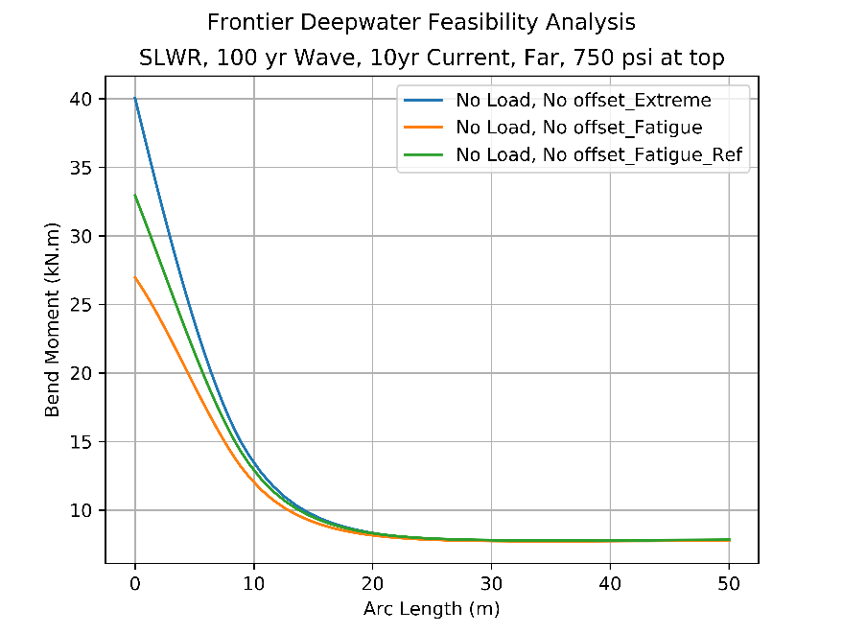

AnchorAdjustment: 34.36

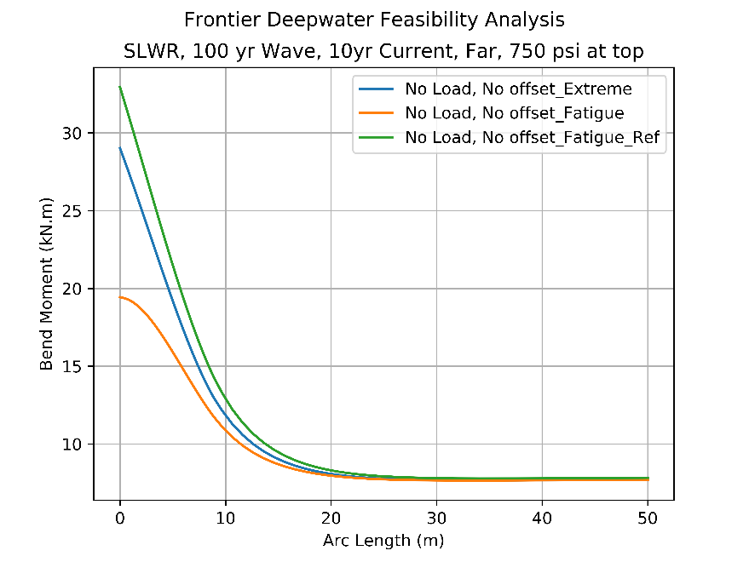

AnchorAdjustment: 11.5

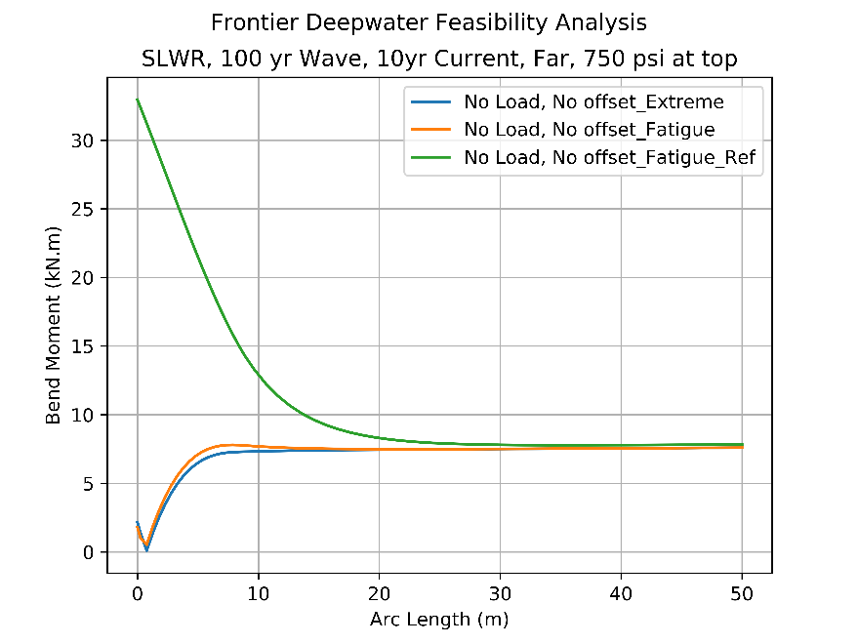

AnchorAdjustment: 13.0

